Calibration Notes 2026
The transition from Excel to Python is ongoing.
The starting point for this analysis is the Git Hub file "UniversalBridge3\spread_sheets\UBcalibrationApril2023.xlsx". This version is initially named “KJ_UBcalibrationApril2023.xlsx" in folder ~\Quality\TECHPROC\E023-Impedance\Universal Bridge\Cal_Jun_2026. The 2023 manually linked to the ‘docx’ tab which was a pasted version of the output file from Python ‘MeasureR.py’.
In GitHub a new script ‘dc_data_in.py’ in the ‘Investigations’ folder summarises the data collected in ‘E3458A_Res_2026-06-11.csv’ and puts it in ‘out_E3458A_Res_2026-06-11.csv’. This makes the manual linking in Excel a little easier and it also adds Python variable names for later integration in a fully Python calculation. This reduces 262 lines to 50 lines plus a summary block of 12 lines for key measurements of the internal standards. Note that the raw data misnamed R4B as R2B.
In the ‘Calibration’ worksheet, there is a highlighted yellow block O6:R16 which will now be mapped through U7:X18 to the values in ‘out_E3458A_Res_2026-06-11’, A51:E63. However, there seems to have been mislabelling of the R4A, R4B and R4C results. Either in the original program or in the summarising program. Appears to be in the data gathering process!
Tim has provided latest value of SR104 and that communication is recorded in the ‘SR104’ worksheet. Temperature calculation is based on the resistance of the copper 10 kΩ, with both formulae (in cells K8 and K9) giving the same answer. The temperature coefficient calculation on the ‘Comparison’ worksheet seems wrong as β varies with temperature. The formula R(temp)=R20*(1+0.342*1e-6*(temp-20)-0.027*1e-6*(temp-20)^2) is given in ~\Ongoing\OHM\StandardResistors\SR102_SR104_2019\SR104_Tco.xls. This formula is used in cell L8 of the ’Calibration’ worksheet.
The summary of ppm errors for the internal resistors is reasonable in terms of history “AUDIREGC.xlsx’.
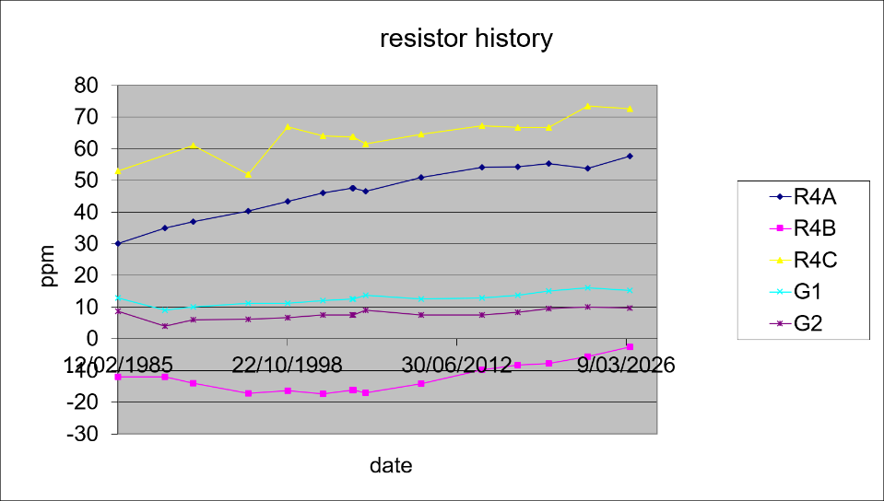
Decide to only use GR1000A for the AH2700 correction rather than the average of the A and B correction. I suspect that GR1000B is mechanically stable but probably exposed to the atmosphere at some level.
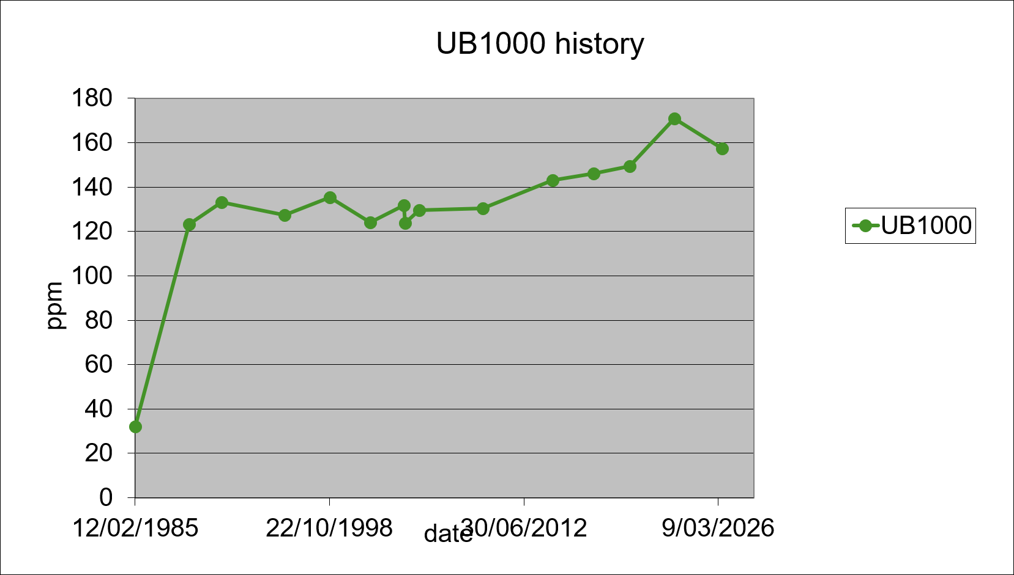

Thompson phase angle measurements are similar to previous results and so no need to change the uncertainty term.

